http://www.mmg.com.au/local-news/heathcote/mt-ida-fire-tower-s-new-cabin-unveiled-1.81840

Mt Ida fire tower’s new cabin will be widely used during the approaching fire season.
BARBARA SUNGAILA October 16, 2014 4:34am

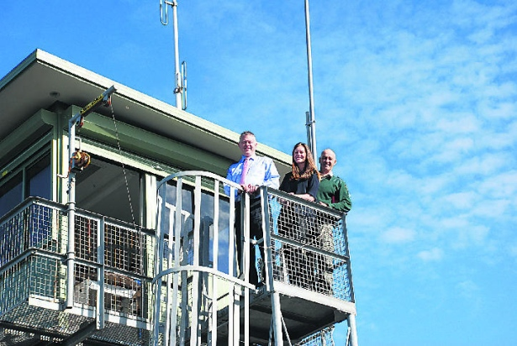
Environment and Climate Change Minister Ryan Smith, Nationals candidate for Euroa Steph Ryan and DEPI fire and land officer Pat McCarthy on the Mt Ida fire tower on Thursday.

The Mt Ida fire tower’s new cabin will keep fire lookout observers cooler and more comfortable as they work 12-hour shifts during summer.
Its windows are larger than its predecessor and are UV and glare resistant; there is also improved access, as well as insulated ceiling and walls.
Environment and Climate Change Minister Ryan Smith inspected the new facility on Thursday.
Mr Smith said early detection of bushfires was vital in restricting their spread and using observers in fire towers was one of the best means of detecting fires in remote areas.
‘‘These fire towers are managed by the Department of Environment and Primary Industries and strategically located to ensure maximum coverage of Victoria’s parks and forests and protection of local communities,’’ Mr Smith said.
‘‘Combined with detection aircrafts, public information and employee patrols, the 66 towers across Victoria provide early detection and a quick response to bushfires.’’
Heathcote-based DEPI fire and land officer Pat McCarthy said the tower would benefit the whole district and the upgrade was important from a health and safety perspective.
‘‘It’s going to be a lot more comfortable for the operator,’’ he said.
‘‘Fatigue management is a big thing with fire tower operators because of the long hours.’’
He said comfort helped alleviate fatigue and the new cabin would be around 5°C cooler than the old one.
‘‘And there’s a bit of flow-through air,’’ he said.
‘‘You’ll be able to have a few more creature comforts up there; a microwave, maybe even an air-conditioner of some sort in the future.’’
Mr McCarthy said good infrastructure was important.
‘‘Everything unfolds from there — good communication, good information coming directly from the person in the tower,’’ he said.
‘‘It’ll just be a great asset to the town.’’
The original Mt Ida fire tower was only 2.7m high and was destroyed in bushfires in early 1987.
It was replaced with a temporary structure for the following fire season and a 10m permanent tower was built in November 1988.
The new cabin was lifted into place on the existing legs and framework.

